SQUARE 20-Screen Master Table
  - Purpose, point-form features, core functions and end-to-end user journey
20 INTERCONNECTED SCREENS  From welcome and consent to analysis and long-term management | 6 FUNCTIONAL GROUPS  Governance, dashboard, processing, interpretation, intervention and monitoring | 1 CONTINUOUS JOURNEY  Upload, understand, act, follow up and improve

User Journey Flow
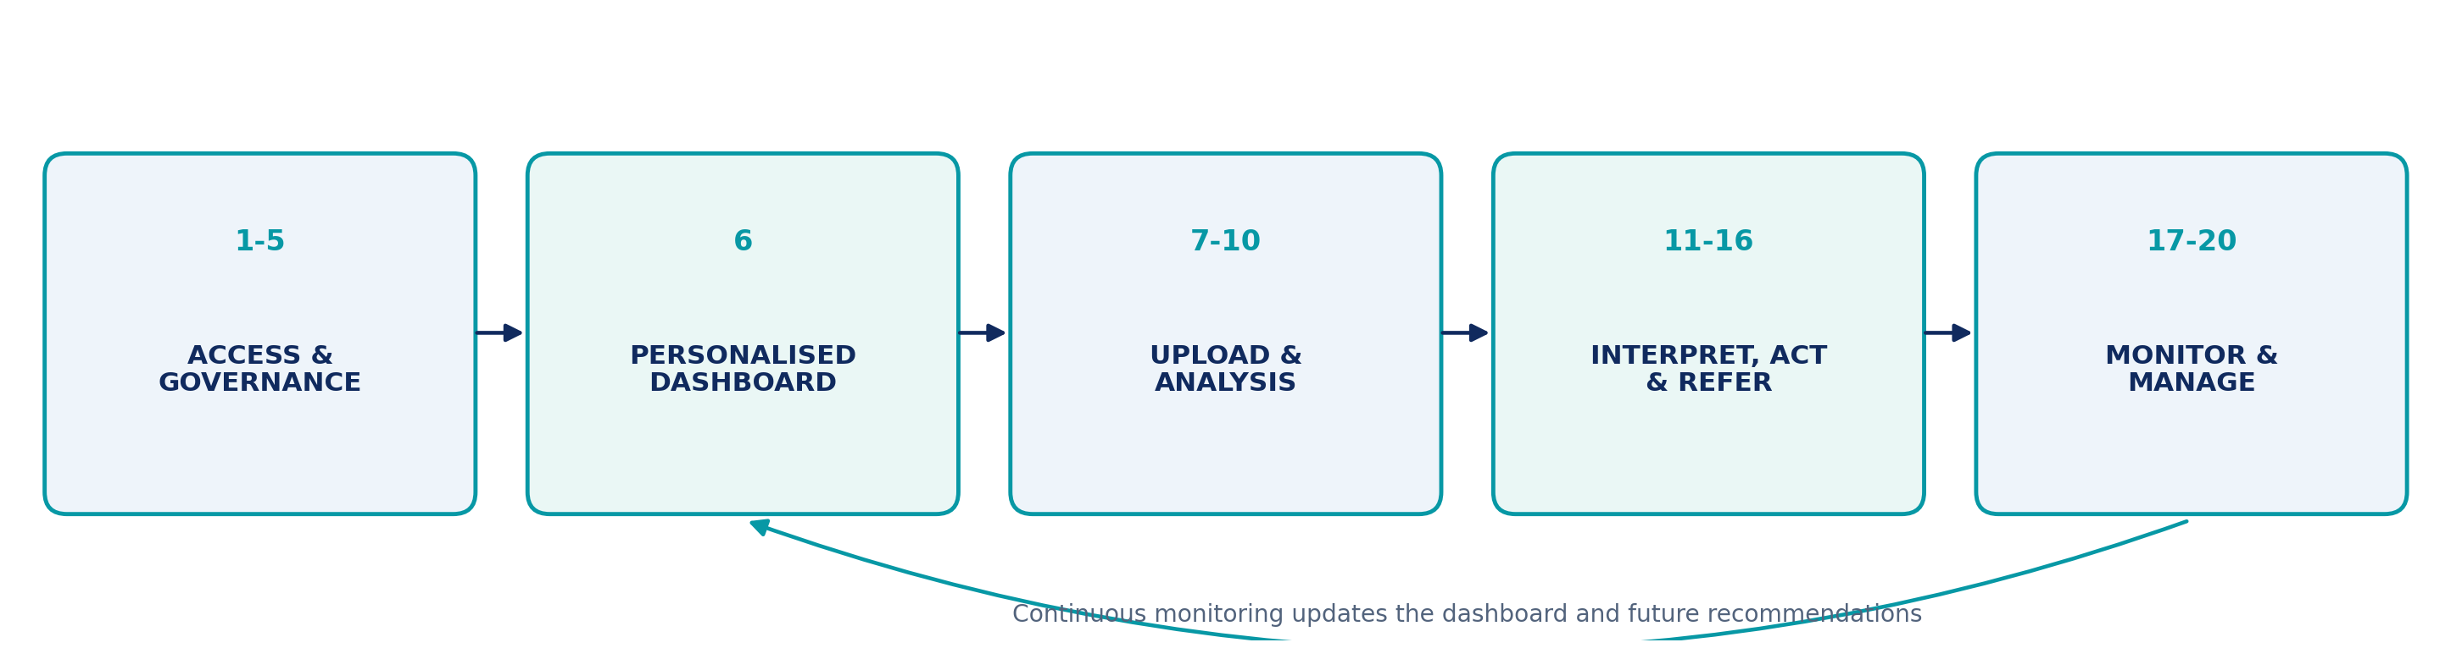
Figure 1. SQUARE user journey from access and consent to continuous monitoring.

How to Read the Master Table
- Purpose explains why the screen exists in the user journey.
- Main features lists the essential interface components in point form.
- Core function / output describes what the screen does or produces for the next stage.

Master Table: All 20 Screens
Each row defines the minimum essential role of one screen. Features may be progressively released while preserving the complete journey logic.
No. | Screen | Purpose | Main Features | Core Function / Output
1 | Welcome Homepage | - Introduce SQUARE  - Explain the core health journey  - Guide new and returning users | - Brand and service overview  - Upload - Understand - Act - Follow Up pathway  - Register and Log In buttons  - Privacy and safety messaging | - Routes users to registration or login  - Establishes trust and platform expectations
2 | Registration Page | - Create a secure account  - Keep initial registration short | - Name and contact details  - Password creation and confirmation  - Basic eligibility confirmation  - Links to Terms, Privacy and Consent | - Creates the user account  - Defers detailed health questions until needed
3 | Log In Page | - Provide secure account access  - Support account recovery | - Email or mobile login  - Password visibility control  - Remember device  - Forgotten-password recovery  - Future multifactor authentication | - Authenticates the user  - Opens the personalised dashboard
4 | Terms and Conditions | - Explain legal rules of platform use  - Record user acceptance | - Readable section navigation  - Version and effective date  - Download option  - Acceptance checkbox  - Privacy Notice link | - Stores accepted version, date and time  - Provides an auditable legal record
5 | Consent Page | - Obtain informed data-processing permission  - Separate required and optional consent | - Required service consent  - Optional research participation  - Communication preferences  - Withdrawal information  - Consent history | - Activates permitted data use  - Keeps research participation voluntary
6 | Personalised Health Dashboard | - Provide the central health overview  - Connect all platform functions | - General health summary  - Priority recommendations  - Anthropometric compartment  - Anatomical domain map with organ status  - Upload, reports, trends, referrals and settings shortcuts | - Acts as the main navigation hub  - Shows current status and next actions
7 | Upload Blood Report | - Collect laboratory reports securely  - Prepare files for extraction | - PDF, JPG and PNG upload  - Camera capture  - Laboratory, date and report type  - File-quality checklist  - Manual-entry fallback  - Recent reports | - Stores the original report  - Starts extraction after validation
8 | Report Recognition and Verification | - Confirm extracted laboratory data  - Prevent scan and formatting errors | - Original report preview  - Editable values, units and ranges  - Confidence indicators  - Uncertain-field flags  - Verification confirmation | - Creates a user-confirmed structured dataset  - Preserves traceability to the original report
9 | Triggered Health Questionnaire | - Collect relevant health context only  - Avoid an unnecessarily long questionnaire | - Adaptive question logic  - Section progress and time estimate  - Autosave  - Why we ask this explanations  - Not sure and Prefer not to answer options  - Automatic skipping | - Adds context for risk and safety assessment  - Personalises interpretation and advice
10 | Analysis Processing | - Show transparent analysis progress  - Explain what the platform is checking | - Data validation  - Unit and reference-range alignment  - Health-domain assessment  - Safety screening  - Recommendation generation  - Completion notification | - Combines verified results, profile and answers  - Produces structured analysis outputs
11 | Health Analysis Summary | - Present the most important findings first  - Avoid overwhelming the user | - General health comment  - Findings needing attention  - Safety priority  - Domain-status overview  - Top three actions  - Referral and download controls | - Produces the executive health summary  - Directs users to details or action
12 | Detailed Blood Results Interpretation | - Explain individual laboratory markers  - Connect values with understandable next steps | - Search and filters  - Value, unit and laboratory range  - Visual range position  - Result trend  - Plain-language meaning  - Influencing factors and suggested actions | - Generates educational marker interpretations  - Avoids presenting results as a diagnosis
13 | Health Domain Details | - Integrate related health information by domain  - Show interactions between risk factors | - Cardiovascular, metabolic, liver, renal, haematology and anthropometric tabs  - Relevant laboratory and profile factors  - Protective factors  - Factors to improve  - Calculator eligibility  - Domain-specific actions | - Produces an integrated domain interpretation  - Prevents isolated marker comments from losing context
14 | Personalised Health Action Plan | - Convert findings into practical actions  - Keep the initial plan manageable | - Three priority actions  - Adjustable targets  - Schedules and reminders  - Completion tracking  - Why this helps explanations  - Later recommendations | - Creates a trackable wellness plan  - Supports gradual behaviour change and follow-up
15 | Referral and Safety Guidance | - Identify the appropriate level of care  - Separate referral from wellness advice | - Emergency, prompt, routine and self-management pathways  - Referral reason and timeframe  - Recommended service type  - Visit preparation checklist  - Symptom-based safety guidance | - Generates clear referral guidance  - Escalates care without claiming a diagnosis
16 | Full Health Report Preview | - Review and customise the generated report  - Control downloading and sharing | - Page and section preview  - Section inclusion controls  - PDF download and printing  - Password protection  - Recipient and access expiry  - Sharing management | - Produces a portable health report  - Keeps disclosure under user control
17 | Health Trends and Progress Tracking | - Monitor changes over time  - Assess data comparability | - Laboratory marker charts  - Blood-pressure trends  - Weight and BMI trends  - Domain trends  - Action-plan completion  - Unit, range and fasting-status checks  - Health timeline | - Supports longitudinal monitoring  - Flags comparisons that may be unreliable
18 | Profile and Health Information | - Maintain health context for future analyses  - Request only missing or outdated information | - Personal details and anthropometrics  - Medical, medication and family history  - Lifestyle information  - Self-reported, device-measured and report-extracted labels  - Quality checks and reminders | - Maintains the current health profile  - Leaves previously generated reports unchanged
19 | Reports Library and Management | - Store and organise reports and analyses  - Preserve source-to-analysis traceability | - Search and filters  - Original and generated file separation  - Drafts and statuses  - Comparison and downloads  - Version history  - Sharing access  - Archive and delete controls | - Provides long-term report management  - Maintains versions and access status
20 | Settings, Privacy and Logout | - Manage preferences, rights and account access  - Keep privacy choices visible | - Account, notifications and security  - Language and accessibility  - Consent and optional research controls  - Data download and retention  - Devices and sharing access  - Support, logout and protected deletion | - Applies account and privacy preferences  - Allows withdrawal, export, logout and controlled deletion

Essential Functional Groups
Functional Group | Screens | Platform Role
Access and Governance | 1-5 | - Introduce the platform  - Create the account  - Establish legal and consent permissions
User Control Centre | 6 | - Provide the central dashboard  - Connect the complete user journey
Data Acquisition and Processing | 7-10 | - Upload and verify data  - Collect triggered context  - Run structured analysis
Health Interpretation | 11-13 | - Summarise findings  - Explain individual markers  - Integrate health domains
Intervention and Escalation | 14-16 | - Create the action plan  - Guide referral and safety decisions  - Generate the full report
Longitudinal Management | 17-20 | - Track progress  - Maintain profile data  - Manage reports, privacy and account settings

Core Journey Logic
1. Access and permission: The user understands the service, creates an account and grants the necessary consent.
2. Data acquisition: The user uploads a report, verifies extracted values and answers only triggered questions.
3. Interpretation: SQUARE generates the overall summary, marker explanations and integrated domain views.
4. Action and escalation: The user receives prioritised actions, referral guidance and a shareable report.
5. Long-term management: New measurements and reports update trends, profile context and future recommendations.
Design principle: Every screen should move the user toward understanding, safe action or longitudinal follow-up without presenting educational interpretation as a medical diagnosis.

